|  |  |  |
| --- | --- | --- |
| Course: | **Mobile Application Development** | Date: 17/04/2024 |
| Course Code: | CSC-341 | Session: II |
| Faculty’s Name: | Dr. Muhammad Asif | Max Marks: 20 |
| Time Allowed: | 1.5 Hours | Total Pages: (3) |

**INSTRUCTIONS:**

1. This is closed book exam. Communication devices and any written material are strictly prohibited.
2. All questions are compulsory.
3. Be brief and to the point please.

Student’s Name: _____________________________Enroll No:______________________

(USE CAPITAL LETTERS)

**Question # 1 (5 Marks) (CLO-1)**

By recalling the **KNOWLEDGE** of Intent and Pending Intent, make an android app in which you can send an SMS by **DESCRIBING** the **SMSManager** class. Make an android app which sends an SMS to any number which is provided by the user. You have to add an **Activity** which contains two **TextViews** (Mobile No. And Message Label), two **EditTexts** (Take input from user Mobile No. and Message) and a **button** (Send SMS). A **Toast** must be appeared after successful sending of an SMS. You have to write **.JAVA** file code and PERMISSION line of code in MANIFEST.XML only. The GUI of an activity should be like as given below.

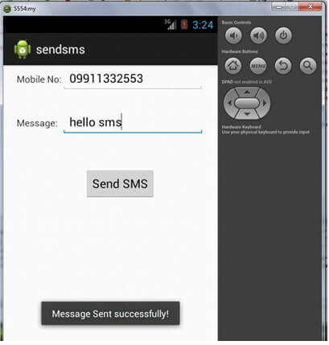

**Question # 2 (7 Marks) (CLO-2)**

By **INTERPRETING** the concept of Pone Call generation, develop an android app which generates a phone call to any number which is provided by the user. You have to add an **Activity** which contains one TextView (Mobile No. ), one **EditText** (Take input from user Mobile No.) and a **button** (Call). You have to write **.JAVA** file code only. The GUI of an activity should be like as given below.

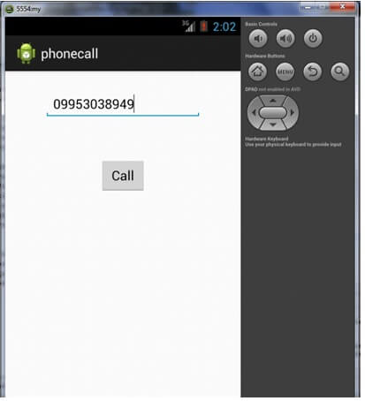

**Question # 3 (8 Marks) (CLO-3)**

**UNDERSTAND** the following problem statement and **SOLVE** by making an android app using IMPLICIT INTENT which redirects the user to a specific website after providing a URL (Uniform Resource Locator). You have to add an **Activity** which contains one **TextView** (Enter URL ), one **EditText** (Take input from user URL) and a **button** (Visit). You have to write **.JAVA** file code. The GUI of an activity should be like as given below.

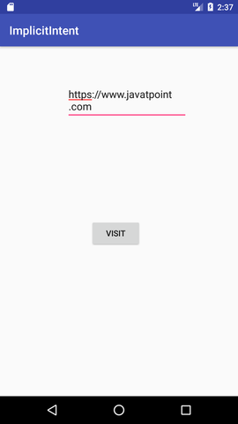

|  |  |
| --- | --- |
| **Keywords table** | |
| SMS Manager | import android.telephony.SmsManager; |
| Getting reference of Widget | Object=(EditText)findViewById(R.id.editText1); |
| Click Listener | .setOnClickListener(new OnClickListener() {  @Override  public void onClick(View arg0) {  }} |
| Toast method | Toast.makeText(Parameter1getcontext, Paremeter2message, Parameter3Tosatlength) |
| Permissions | <uses-permission android:name="android.permission.SEND_SMS”/>  <uses-permission android:name="android.permission.INTERNET”/> |
| Phone call Manager | import android.content.Intent;  import android.app.PendingIntent;  import android.net.Uri; |
| Call Intent | Intent.ACTION_CALL, setData(uri) |

**Best of Luck**